RabbitMQ Configuration with WSO2 EI Server

Objective:
The objective of this application is to push and pull the data to/from the RabbitMQ broker. The sample contains two proxy services: Producer Service and Consumer Service This document provides details about how to integrate RabbitMQ with WSO2.
Prerequisites: The following software are need to be installed.
- RabbitMQ message Broker
- WSO2 EI (6.6.0)
Before executing the use cases, you need to connect WSO2 Enterprise Integrator server to RabbitMQ.

RabbitMQ: RabbitMQ is a widely used open-source message broker that helps in scaling the application by deploying a message queuing mechanism in between the two applications. It offers temporary storage for data preventing data loss. RabbitMQ Queue takes messages from the publisher and sends them to the consumer.

Installing RabbitMQ:
Install the erlang distribution:
- You can copy the following URL to your browser and download latest .exe file.
https://www.erlang.org/downloads
- Run otp_win64_25.3 and install erlang.

Download and Install RabbitMQ:
- Download the RabbitMQ distribution to the desired location.
- You can copy the following URL to your browser and download latest .exe file.
https://www.rabbitmq.com/install-windows.html#service
Run rabbitmq-server-xxxx.exe file and install rabbitmq-server.
- Navigate to the <RABBITMQ_HOME>/sbin folder (where <RABBITMQ_HOME> is the location of the extracted RabbitMQ distribution) and execute the following command.
rabbitmq-server -detached (windows)
sudo ./rabbitmq-server -detached (Linux)
- To enable the management plugin, execute the following command:
rabbitmq-plugins enable rabbitmq_management (windows)
sudo ./rabbitmq-plugins enable rabbitmq_management (Linux)
- To run rabbitmq server use command:
rabbitmq-server.bat
Note :In my case, my rabbitmq server is located at
C:\Program Files\RabbitMQ Server\rabbitmq_server-3.11.11\sbin>
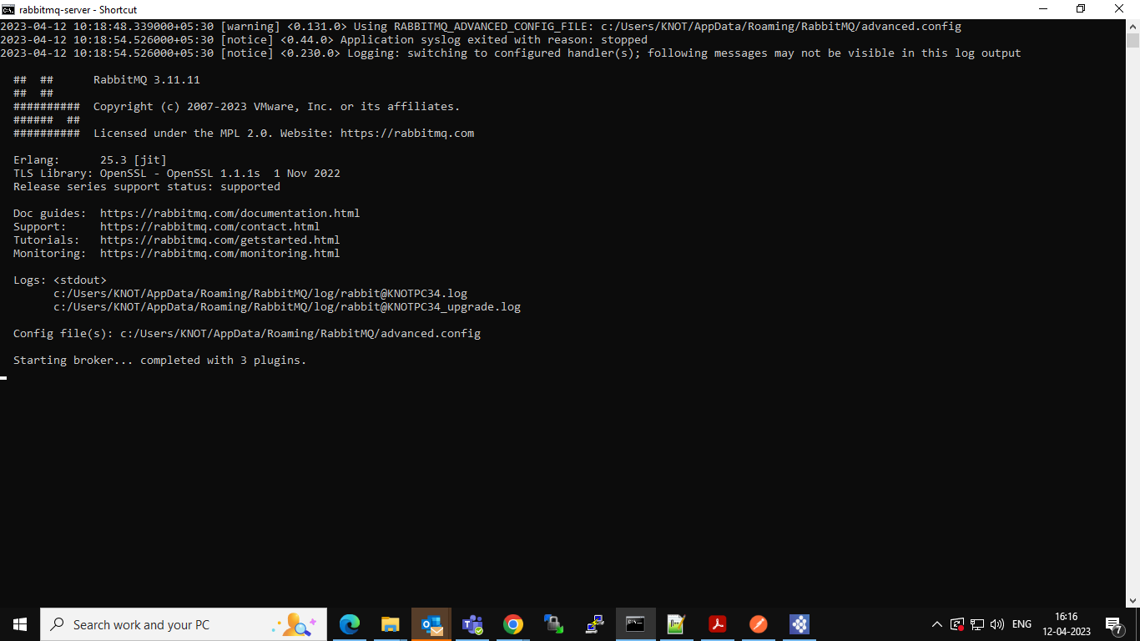

- RabbitMQ server is running at 15672 ports by default, default credentials are guest/guest.
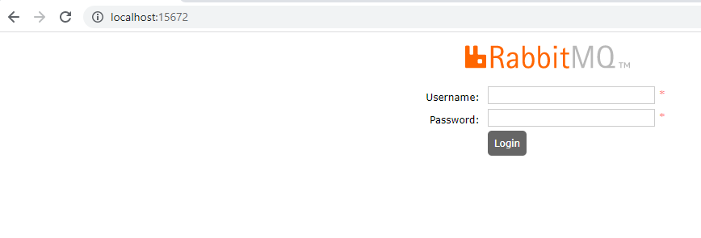

Connecting to RabbitMQ:
Enabling the RabbitMQ Sender and Listener:
- Uncomment the following parameters in the axis2.xml file to configure the RabbitMQ listener and sender.
Axis2.xml file is located at C:\Program Files\WSO2\Enterprise Integrator\6.6.0\conf\axis2\axis2.xml
Source code for listener:
<transportReceiver class="org.apache.axis2.transport.rabbitmq.RabbitMQListener" name="rabbitmq">
<parameter locked="false" name="AMQPConnectionFactory">
<parameter locked="false" name="rabbitmq.server.host.name">localhost</parameter>
<parameter locked="false" name="rabbitmq.server.port">5672</parameter>
<parameter locked="false" name="rabbitmq.server.user.name">guest</parameter>
<parameter locked="false" name="rabbitmq.server.password">guest</parameter>
<parameter locked="false" name="rabbitmq.connection.retry.interval">10000</parameter>
<parameter locked="false" name="rabbitmq.connection.retry.count">5</parameter>
</parameter>
</transportReceiver>
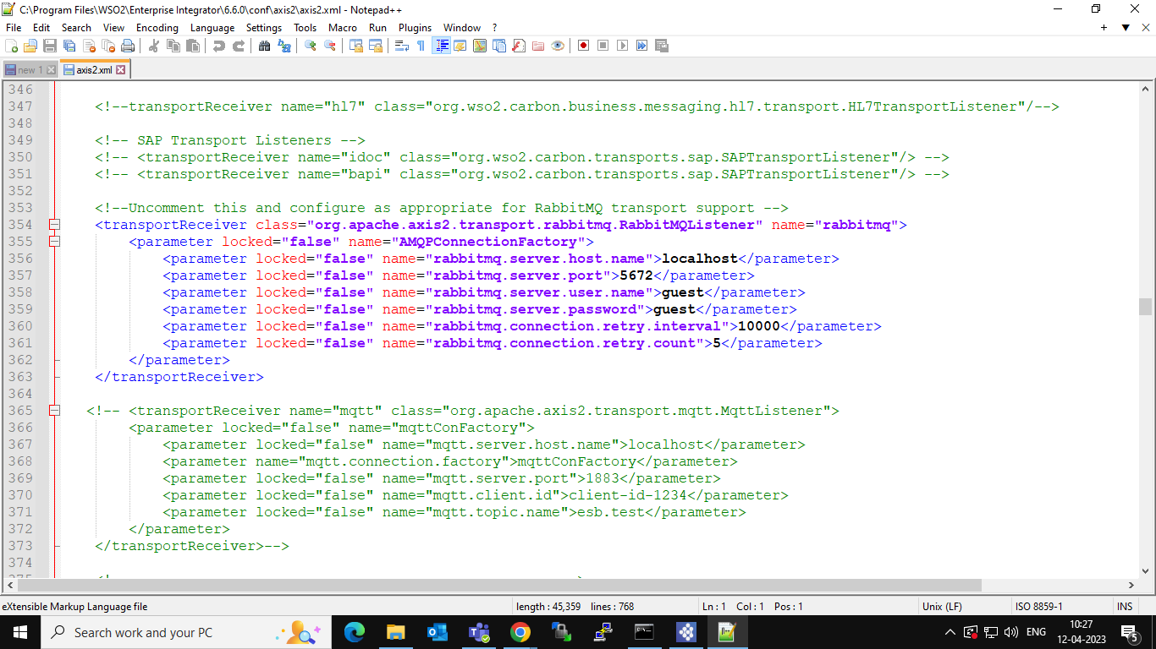

Source code for sender:
<transportSender class="org.apache.axis2.transport.rabbitmq.RabbitMQSender" name="rabbitmq">
<parameter locked="false" name="AMQPConnectionFactory">
<parameter locked="false" name="rabbitmq.server.host.name">localhost</parameter>
<parameter locked="false" name="rabbitmq.server.port">5672</parameter>
<parameter locked="false" name="rabbitmq.server.user.name">guest</parameter>
<parameter locked="false" name="rabbitmq.server.password">guest</parameter>
</parameter>
</transportSender>
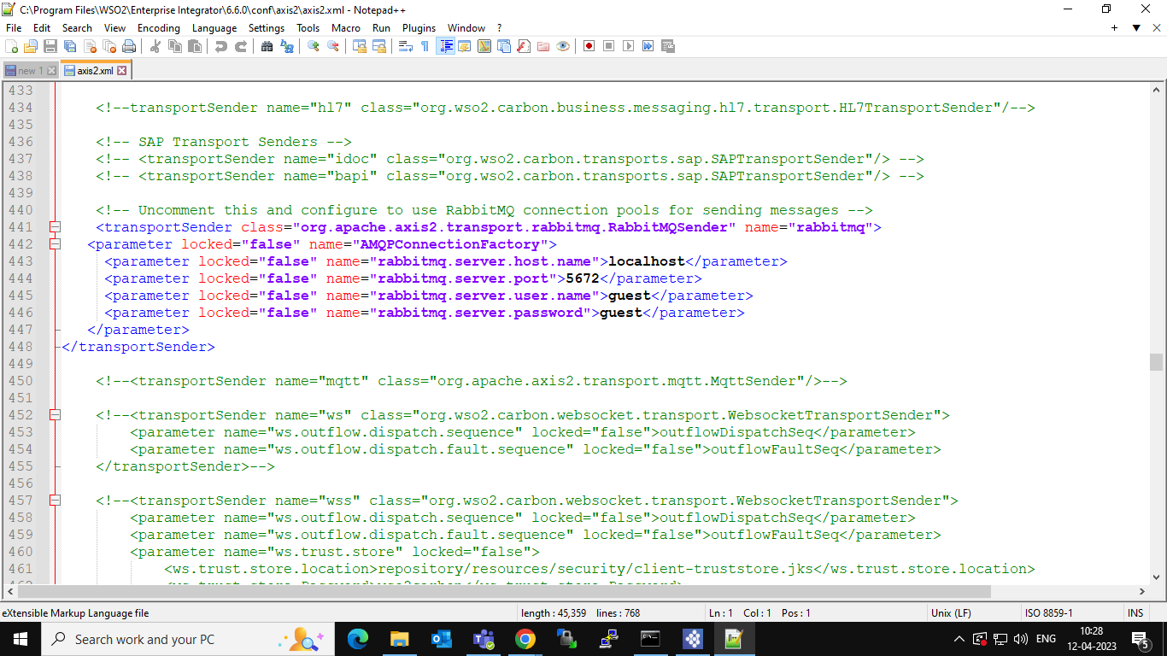

RabbitMQ Producer:
- Open WSO2 Integration Studio and click File → New → Integration Project.
While creating the Integration project click the check box of Create ESB Configs, Create Composite Exporter these two modules are sufficient for this example.

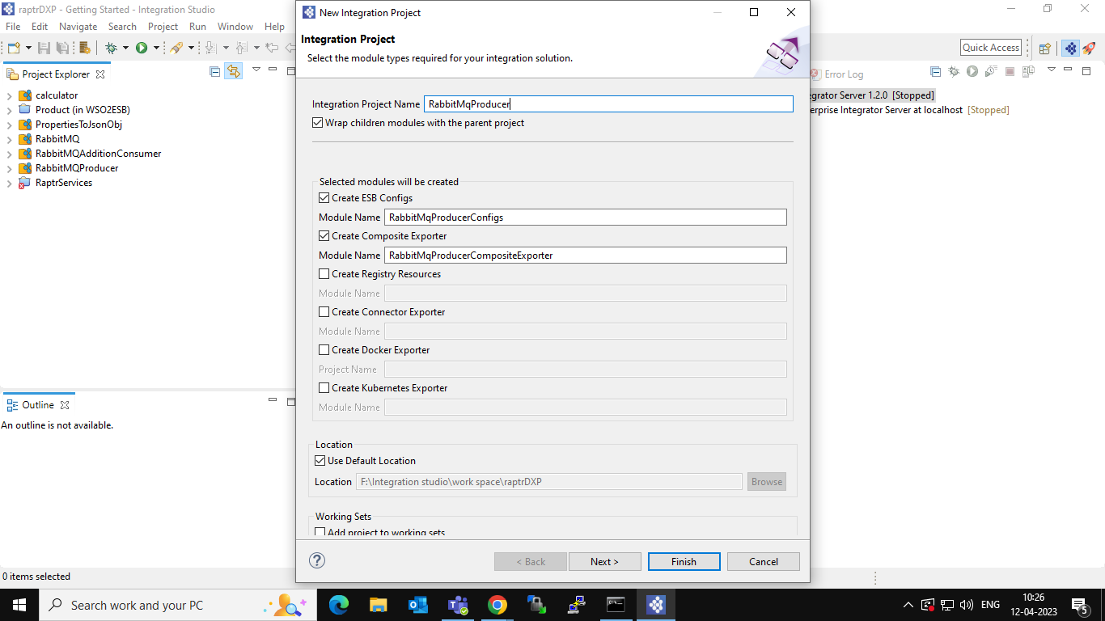

- Right click on RabbitMqProducerConfig → New → Proxy Service → select Create a new proxy service → click next → enter a proxy service name and click Finish. as shown below.

- Open source and copy paste the code as shown below and save it.
<?xml version="1.0" encoding="UTF-8"?>
<proxy name="AMQPProducerSample" startOnLoad="true" transports="http https" xmlns="http://ws.apache.org/ns/synapse">
<target>
<inSequence>
<property description="Initiate asynchronus mediation flow" name="OUT_ONLY" scope="default" type="STRING" value="true"/>
<property description="Generete 202 response from mediation flow" name="FORCE_SC_ACCEPTED" scope="axis2" type="STRING" value="true"/>
<send>
<endpoint>
<address uri="rabbitmq:/AMQPProducerSample?rabbitmq.server.host.name=localhost&amp; rabbitmq.server.port=5672&amp;
rabbitmq.queue.name=ReqQueue&amp;rabbitmq.queue.route.key=ReqKey&amp;ra bbitmq.exchange.name=ReqExchange">
<suspendOnFailure>
<initialDuration>-1</initialDuration>
<progressionFactor>1</progressionFactor>
</suspendOnFailure>
<markForSuspension>
<retriesBeforeSuspension>0</retriesBeforeSuspension>
</markForSuspension>
</address>
</endpoint>
</send>
</inSequence>
<outSequence>
<send/>
</outSequence>
<faultSequence/>
</target>
</proxy>

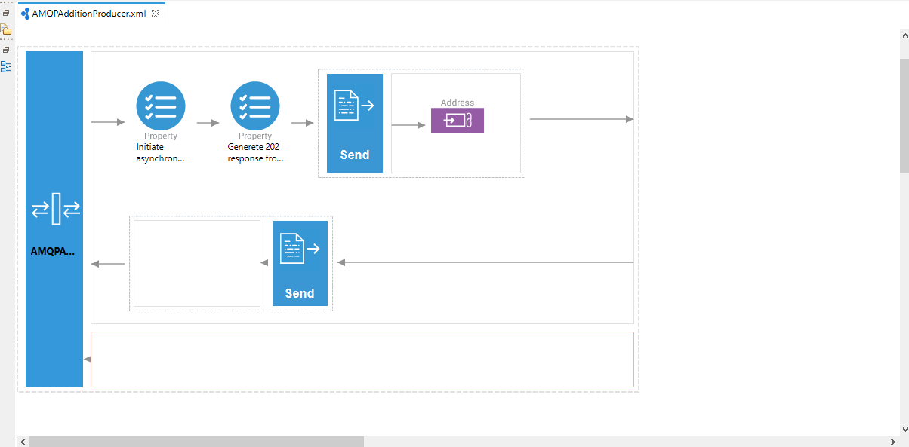

- Right click on Enterprise Integrator server and click Add and Remove and select RabbitMQProducerCompositeExporter, after successful deployment of CAR file you can see the successful deployment log in the console as shown in below figure.
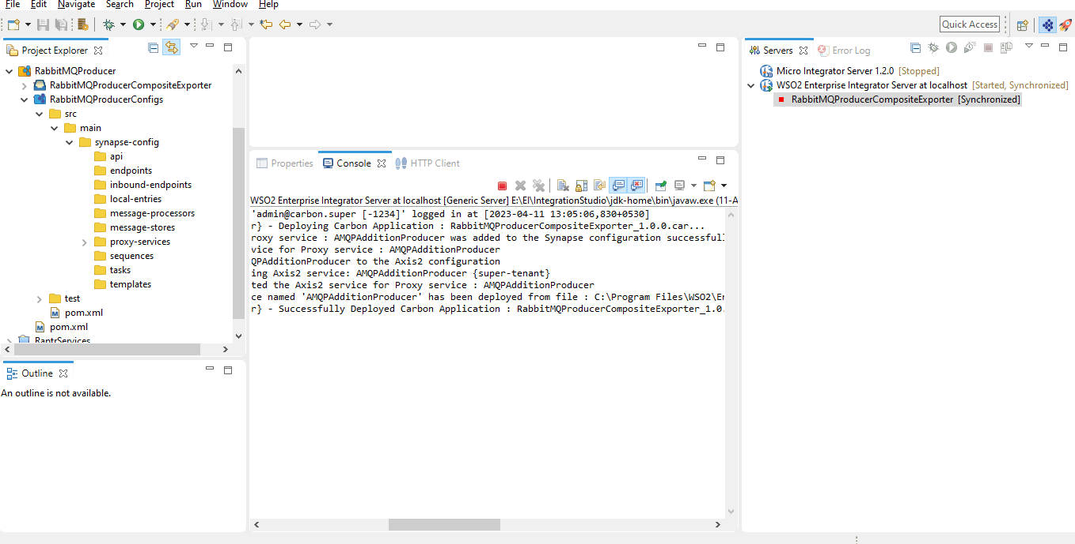

- login into the EI admin console by using credentials admin/admin.
WSO2 Enterprise Integrator (WSO2 EI)

After log, check the Producer service in Services->List.

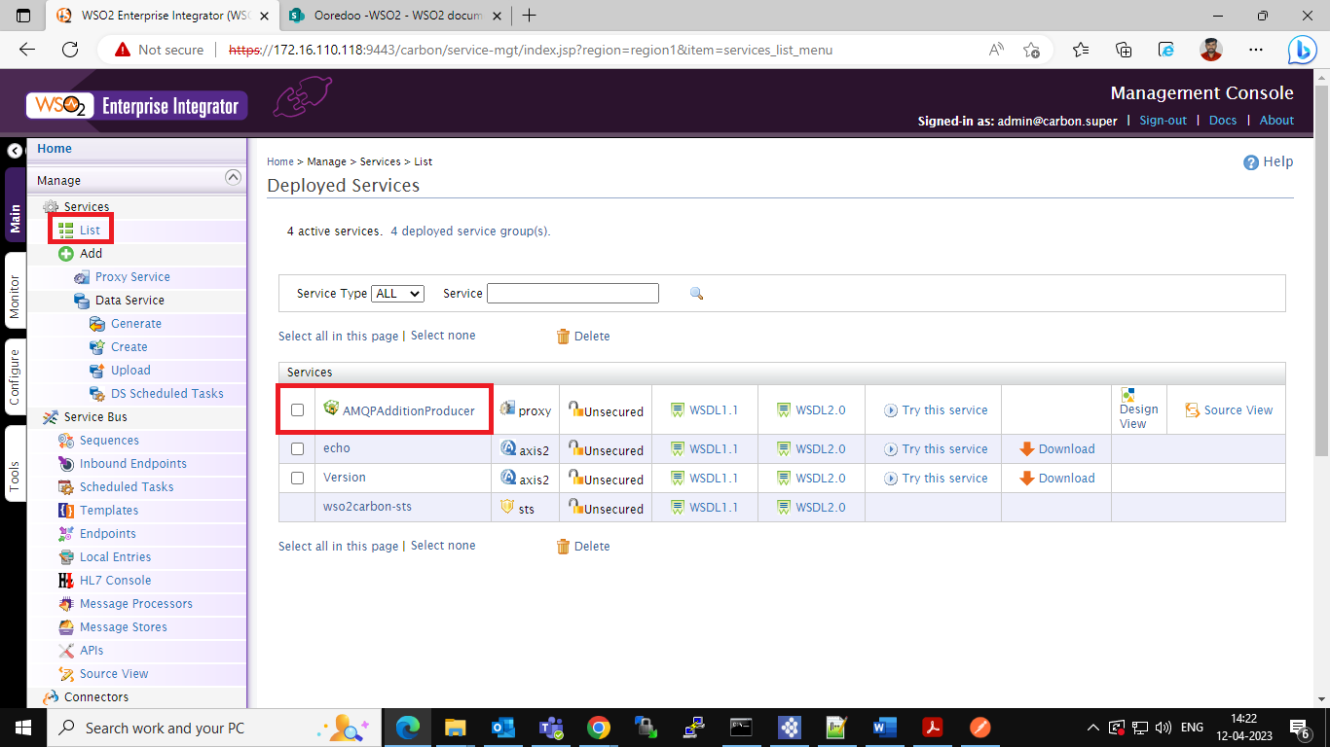

- In the List of services as shown in above figure click on your RabbitMQ Producer service it will open another page there you can find the Endpoint of your service.
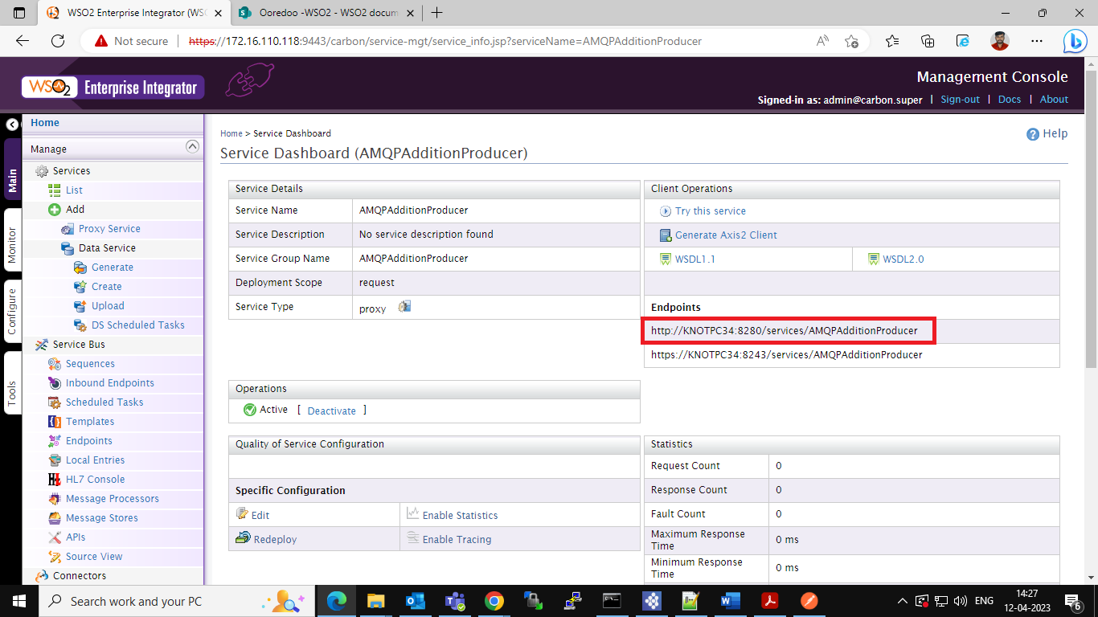

- Send message to the RabbitMQ,
- Open the postman, copy the RabbitMQ producer URL (In the above figure highlighted) paste in the post man URL search box.
- This is a post service, use POST as a method and fill the body with following data.
{
“YourName”:”Prashanth”
}
- For your reference see the below figure.
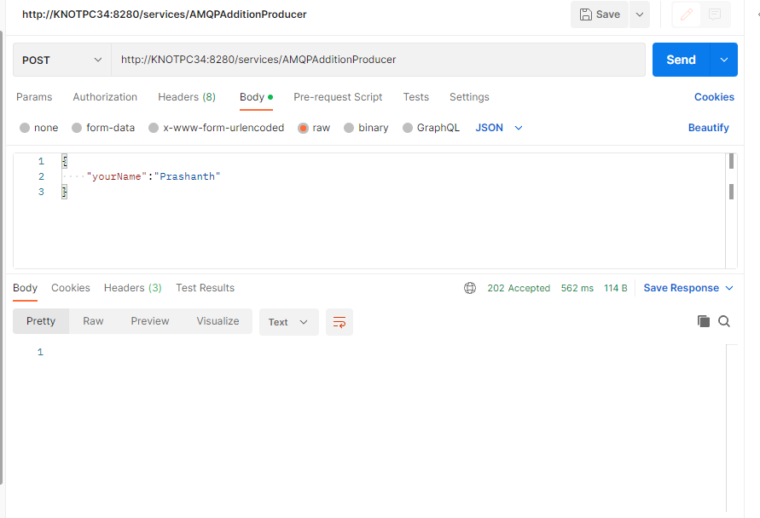

- Now open rabbitmq-server console and click on Queues there you can see the queue with the name ReqQueue, in this you can see the number of messages is in the queue in Ready column.
http://localhost:15672/#/queues

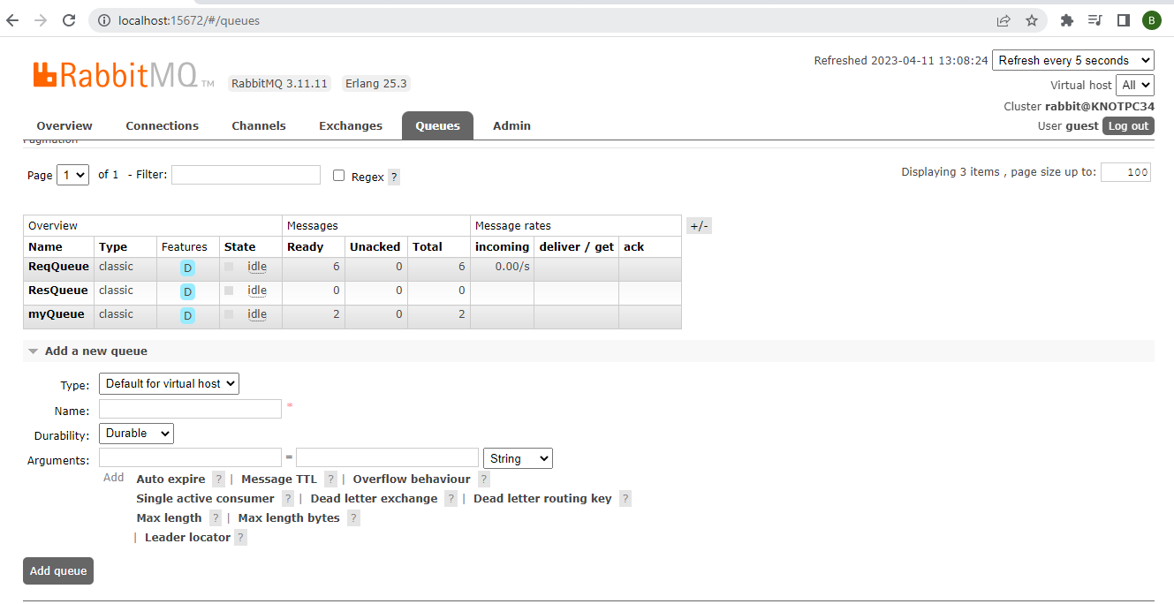

- In the RabbitMQ server you can see the queued messages under Get Messages tab.

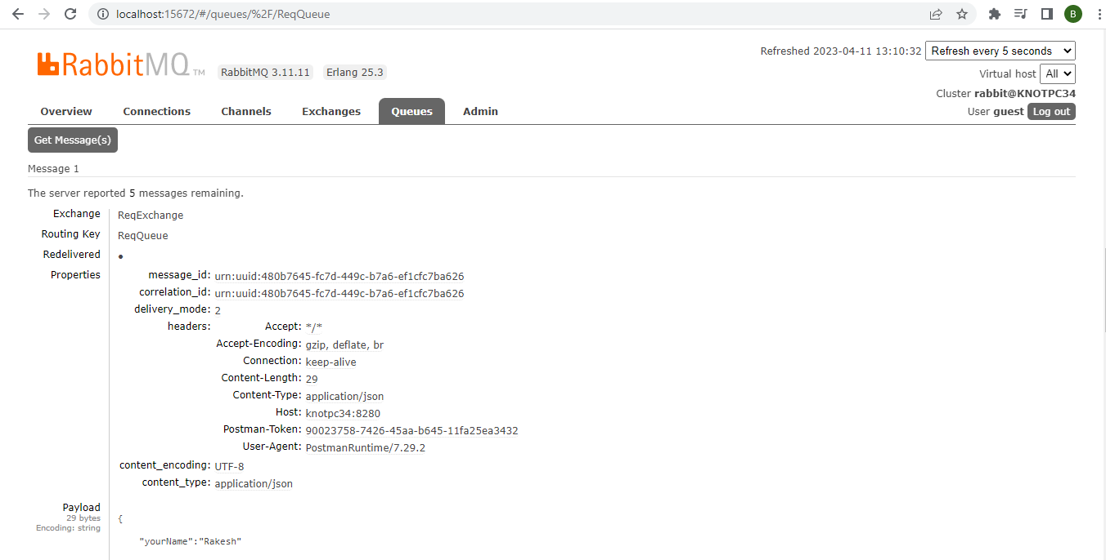

RabbitMQ Consumer:

- Create an Integration project for consumer, Repeat the steps in RabbitMQ Producer from 1 to 2 with name as RabbitMqConsumer.

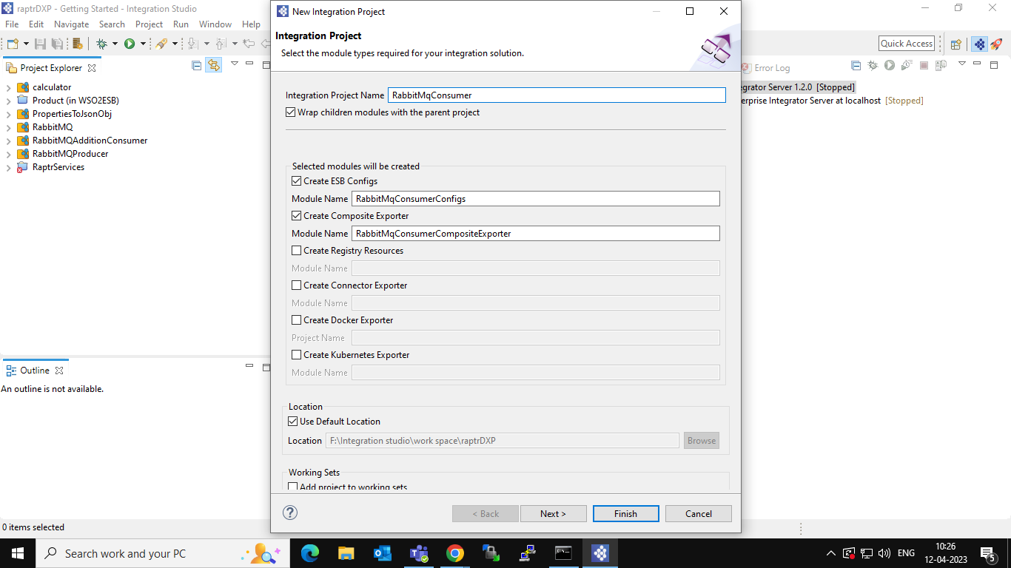

- Create a sequence in this we can add calling other services which takes consumed messages from the queue and process on it or write any logic sequence as per the requirement.
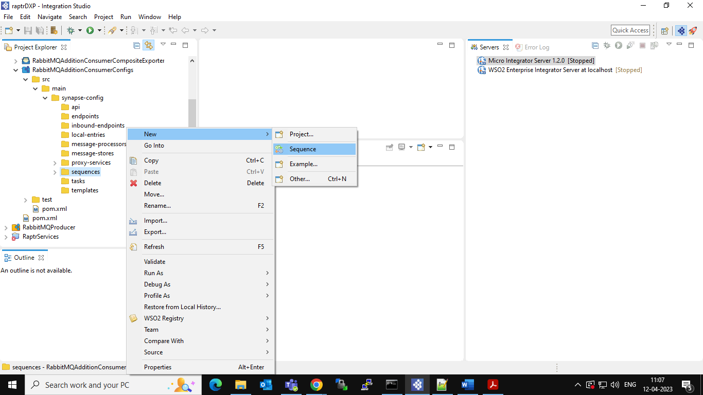

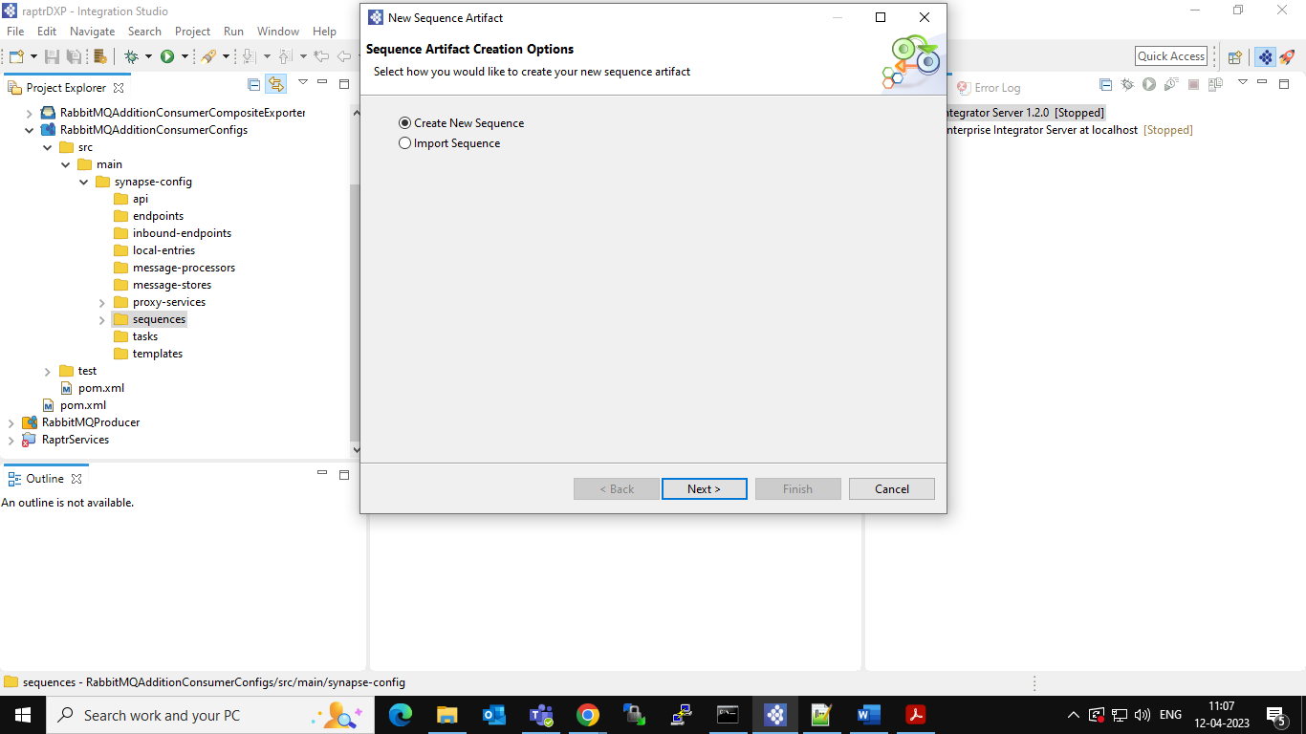

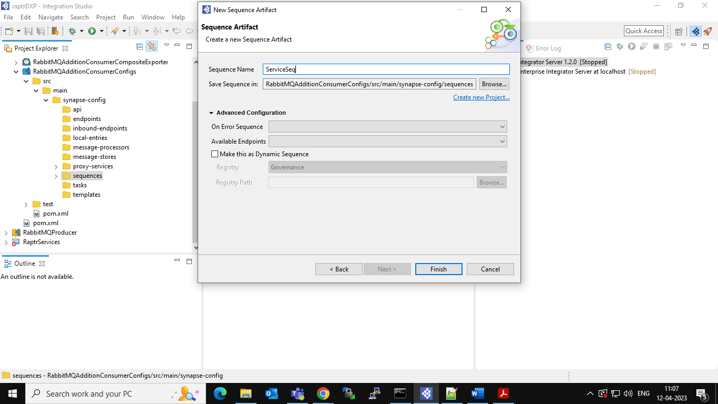

- In this sequence am calling one get method service this will give the following response.

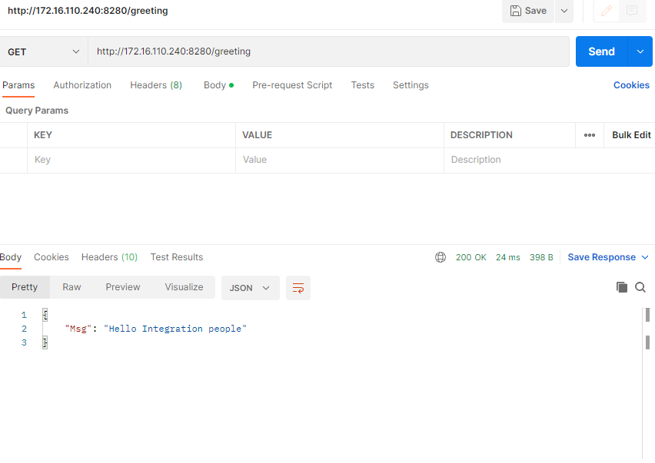
- In ServiceSeq sequence open the source and copy paste the following code.

<?xml version="1.0" encoding="UTF-8"?>
<sequence name="ServiceSeq" trace="disable" xmlns="http://ws.apache.org/ns/synapse">
<call>
<endpoint>
<http method="get" uri-template="http://172.16.110.240:8280/greeting">
<suspendOnFailure>
<initialDuration>-1</initialDuration>
<progressionFactor>-1</progressionFactor>
<maximumDuration>0</maximumDuration>
</suspendOnFailure>
<markForSuspension>
<retriesBeforeSuspension>0</retriesBeforeSuspension>
</markForSuspension>
</http>
</endpoint>
</call>
</sequence>

- Create a proxy service with the name AMQPConsumer, In the Proxy service open the source and copy paste the code as shown below and save it.

<?xml version="1.0" encoding="UTF-8"?>
<proxy name="AMQPConsumer" startOnLoad="true" transports="rabbitmq" xmlns="http://ws.apache.org/ns/synapse">
<target>
<inSequence>
<property expression="json-eval($.yourName)" name="Name" scope="default" type="STRING"/>
<log level="custom">
<property expression="get-property('Name')" name="Req"/>
</log>
<sequence key="ServiceSeq"/>
<property expression="json-eval($.Msg)" name="Greeting" scope="default" type="STRING"/>
<log level="custom">
<property expression="fn:concat(get-property('Greeting'),',',get-property('Name'))" name="Res"/>
</log>
<payloadFactory media-type="json">
<format>{&#xd;
"Res":$1&#xd;
}</format>
<args>
<arg evaluator="xml" expression="fn:concat(get-property('Greeting'),',',get-property('Name'))"/>
</args>
</payloadFactory>
<send>
<endpoint>
<address uri="rabbitmq:/AMQPAdditionConsumer?rabbitmq.server.host.name=localhost&amp;rabbitmq.server.port=5672&amp;
rabbitmq.queue.name=ResQueue&amp;rabbitmq.queue.route.key=ResKey&amp;rabbitmq.exchange.name=ResExchange">
<suspendOnFailure>
<initialDuration>-1</initialDuration>
<progressionFactor>-1</progressionFactor>
<maximumDuration>0</maximumDuration>
</suspendOnFailure>
<markForSuspension>
<retriesBeforeSuspension>0</retriesBeforeSuspension>
</markForSuspension>
</address>
</endpoint>
</send>
</inSequence>
<outSequence/>
<faultSequence/>
</target>
<parameter name="rabbitmq.queue.routing.key">ReqKey</parameter>
<parameter name="rabbitmq.exchange.name">ReqExchange</parameter>
<parameter name="rabbitmq.queue.name">ReqQueue</parameter>
<parameter name="rabbitmq.connection.factory">AMQPConnectionFactory</parameter>
</proxy>

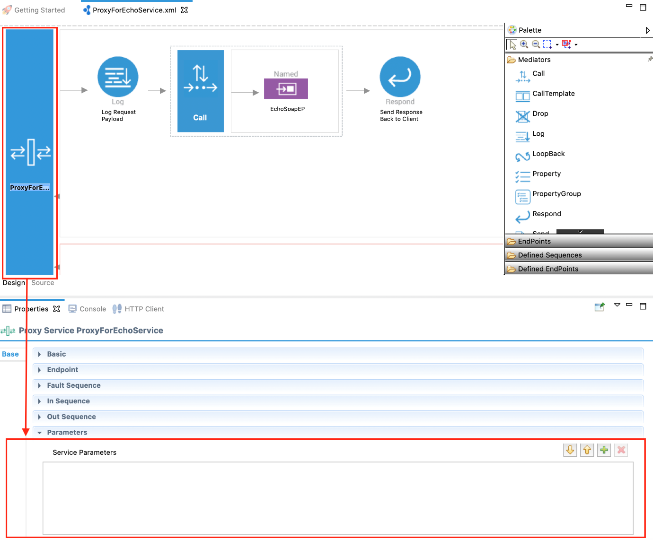

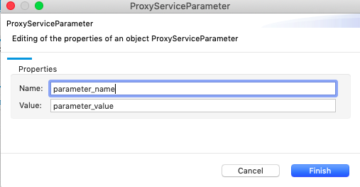

- In the above source code there are few rabbitmq parameters these are mandatory when you implement an integration use case that requires a RabbitMQ connection, you can use the following RabbitMQ parameters in your proxy service artifact.

https://ei.docs.wso2.com/en/latest/micro-integrator/references/synapse-properties/transport-parameters/rabbitmq-transport-parameters/

- In this consumer objective is to consume the message from the message store and appending that message to above backend service message.

- Deploy the RabbitMQConsumerCompositeExporter in the Enterprise Integration server after deployment you can see the output in the console.
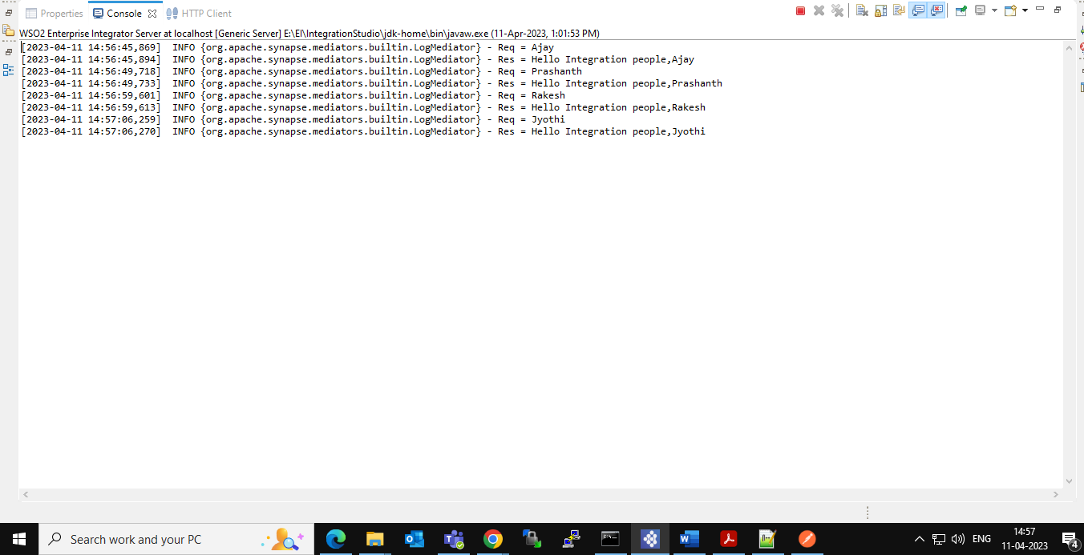

Example:
- RabbitMQ producer Request:
{
“yourName”:”Prashanth”
}

- Backend service response:
{
“Msg”:”Hello Integration people”
}

- RabbitMQ consumer output:
Hello Integration people, Prashanth

- The result also written into another queue.

